**Lab 14**

**Name :-** Aryan Dilipbhai Langhanoja

**Date :-** 11-09-2023

**Enrollment No :-** 92200133030

**CO1: To write, test, and debug simple Python programs**

**CO2: To implement Python programs with conditional, loops and functions**

**Task 1:- How to Add Title to Subplots in Matplotlib (Using set_title() method)**

**Python Code:**

import numpy as np

import matplotlib.pyplot as plt

x = np.array([1, 2, 3, 4, 5])

fig, ax = plt.subplots(2, 2)

ax[0, 0].plot(x, x)

ax[0, 1].plot(x, x*2)

ax[1, 0].plot(x, x*x)

ax[1, 1].plot(x, x*x*x)

ax[0, 0].set_title("Linear")

ax[0, 1].set_title("Double")

ax[1, 0].set_title("Square")

ax[1, 1].set_title("Cube")

fig.tight_layout()

plt.show()

**Output:**

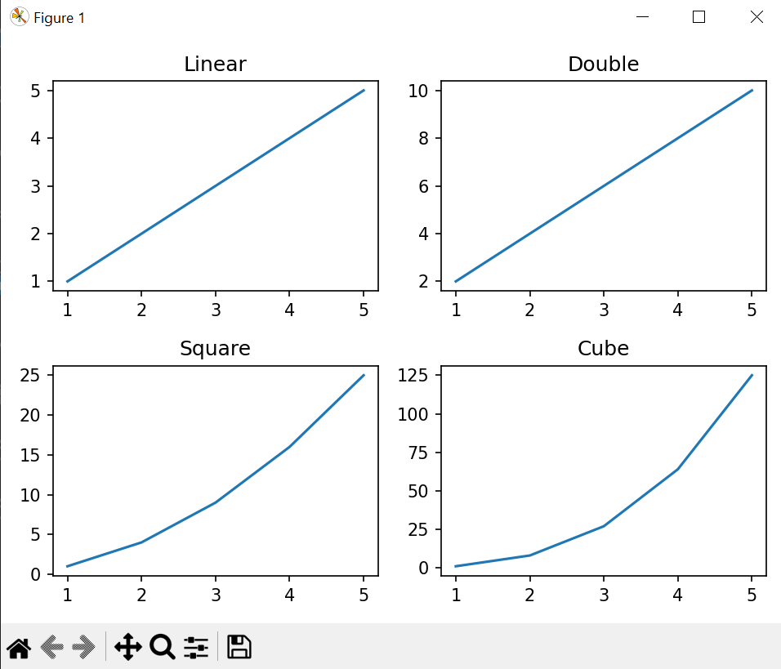

**Task 2:- (Using title.set_text() method)**

**Python Code:**

import numpy as np

import matplotlib.pyplot as plt

x=np.array([1, 2, 3, 4, 5])

fig, ax = plt.subplots(2, 2)

ax[0, 0].plot(x, x)

ax[0, 1].plot(x, x*2)

ax[1, 0].plot(x, x*x)

ax[1, 1].plot(x, x*x*x)

ax[0, 0].title.set_text("Linear")

ax[0, 1].title.set_text("Double")

ax[1, 0].title.set_text("Square")

ax[1, 1].title.set_text("Cube")

fig.tight_layout()

plt.show()

**Output:**



**Task 3:- (Using plt.gca().set_title() method)**

**Python Code:**

import numpy as np

import matplotlib.pyplot as plt

x=np.array([1, 2, 3, 4, 5])

fig, ax = plt.subplots(2, 2)

title = ["Linear", "Double", "Square", "Cube"]

y = [x, x*2, x*x, x*x*x]

for i in range(4):

plt.subplot(2, 2, i+1)

plt.plot(x, y[i])

plt.gca().set_title(title[i])

fig.tight_layout()

plt.show()

**Output:**



**Task 4:-** **(Using plt.gca().title.set_text() method)Python Code:**

import numpy as np

import matplotlib.pyplot as plt

x=np.array([1, 2, 3, 4, 5])

fig, ax = plt.subplots(2, 2)

title = ["Linear","Double","Square","Cube"]

y = [x, x*2, x*x, x*x*x]

for i in range(4):

plt.subplot(2, 2, i+1)

plt.plot(x, y[i])

plt.gca().title.set_text(title[i])

fig.tight_layout()

plt.show()

**Output:**

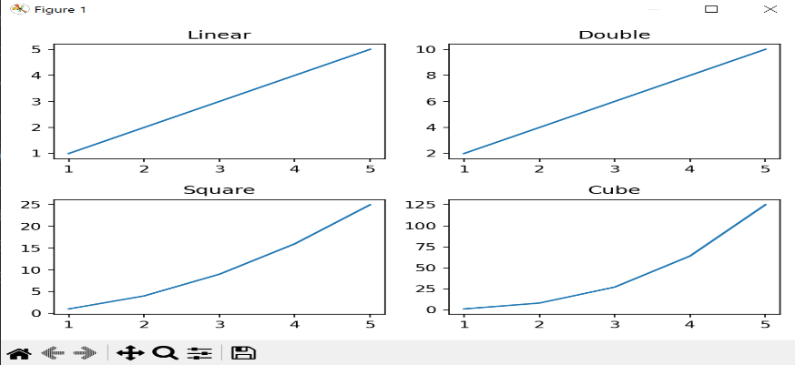

**Task 5:-** **Setting a Single Title for All the** **Subplots Example - 1**

**Python Code:**

import matplotlib.pyplot as plt

import numpy as np

fig, ax = plt.subplots(2, 2)

ax[0][0].plot(np.random.randint(0, 5, 5), np.random.randint(0, 5, 5))

ax[0][1].plot(np.random.randint(0, 5, 5), np.random.randint(0, 5, 5))

ax[1][0].plot(np.random.randint(0, 5, 5), np.random.randint(0, 5, 5))

ax[1][1].plot(np.random.randint(0, 5, 5), np.random.randint(0, 5, 5))

fig.suptitle(' Set a Single Main Title for All the Subplots ', fontsize=30)

plt.show()

**Output:**

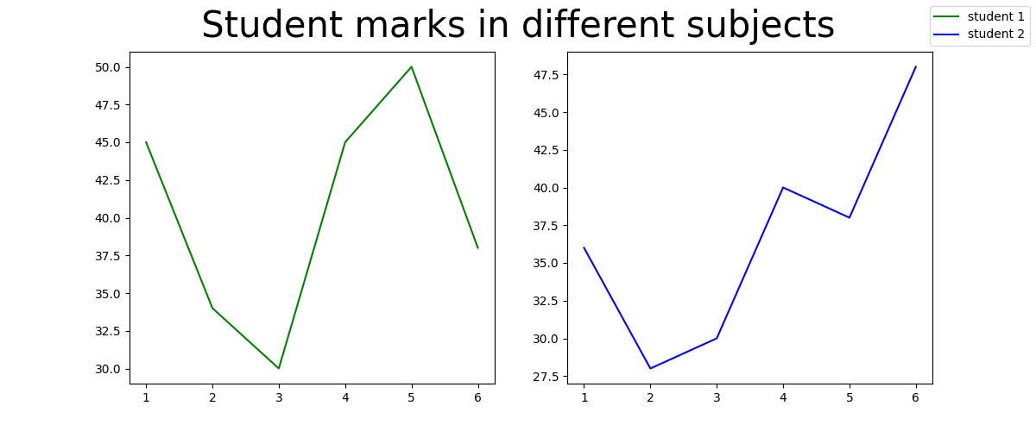

**Task 6:-** **Setting a Single Title for All the** **Subplots Example - 1**

**Python Code:**

import matplotlib.pyplot as plt

fig, (ax1, ax2) = plt.subplots(1, 2, figsize=(12, 5))

x1 = [1, 2, 3, 4, 5, 6]

y1 = [45, 34, 30, 45, 50, 38]

y2 = [36, 28, 30, 40, 38, 48]

labels = ["student 1", "student 2"]

fig.suptitle(' Student marks in different subjects ', fontsize=30)

l1 = ax1.plot(x1, y1 , color = 'g')

l2 = ax2.plot(x1, y2 , color = 'b')

fig.legend([l1, l2], labels=labels,

loc="upper right")

plt.subplots_adjust(right=0.9)

plt.show()

**Output:**



**Task 5:-** **How to Turn Off the Axes for Subplots in Matplotlib?** **Using matplotlib.axes.Axes.axis()**

**Python Code:**

import matplotlib.pyplot as plt

import matplotlib.tri as mtri

import numpy as np

x = np.asarray([0, 1, 2, 3, 0.5,

1.5, 2.5, 1, 2,

1.5])

y = np.asarray([0, 0, 0, 0, 1.0,

1.0, 1.0, 2, 2,

3.0])

triangles = [[0, 1, 4], [1, 5, 4],

[2, 6, 5], [4, 5, 7],

[5, 6, 8], [5, 8, 7],

[7, 8, 9], [1, 2, 5],

[2, 3, 6]]

triang = mtri.Triangulation(x, y, triangles)

z = np.cos(1.5 * x) * np.cos(1.5 * y)

fig, axs = plt.subplots()

axs.tricontourf(triang, z)

axs.triplot(triang, 'go-', color ='white')

axs.set_axis_off()

axs.set_title('Triangle illustration')

plt.show()

**Output:**

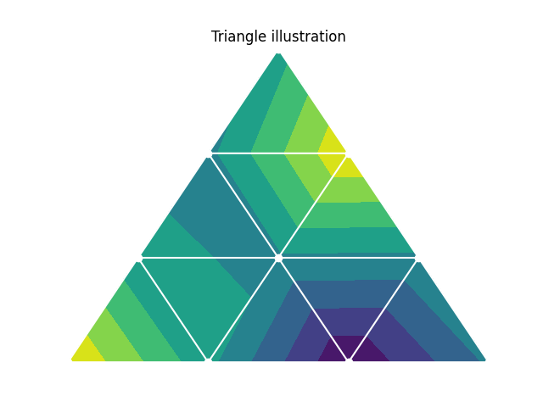

**Task 6:-** **How to Turn Off the Axes for Subplots in Matplotlib?** **Using matplotlib.pyplot.axis()**

**Python Code:**

import matplotlib.pyplot as plt

import numpy as np

geeksx = np.array([24.40, 110.25, 20.05,

22.00, 61.90, 7.80,

15.00])

geeksy = np.array([24.40, 110.25, 20.05,

22.00, 61.90, 7.80,

15.00])

fig, ax = plt.subplots()

ax.xcorr(geeksx, geeksy, maxlags = 6,

color ="green")

ax.set_axis_off()

ax.set_title('Time series graph')

plt.show()

**Output:**



**Task 6:-** **How to Create Different Subplot Sizes in Matplotlib? Create Different Subplot Sizes in Matplotlib using Gridspec**

**Python Code:**

import matplotlib.pyplot as plt

from matplotlib import gridspec

import numpy as np

fig = plt.figure()

fig.set_figheight(8)

fig.set_figwidth(8)

spec = gridspec.GridSpec(ncols=2, nrows=2,

width_ratios=[2, 1], wspace=0.5,

hspace=0.5, height_ratios=[1, 2])

x = np.arange(0, 10, 0.1)

y = np.cos(x)

ax0 = fig.add_subplot(spec[0])

ax0.plot(x, y)

ax1 = fig.add_subplot(spec[1])

ax1.plot(x, y)

ax2 = fig.add_subplot(spec[2])

ax2.plot(x, y)

ax3 = fig.add_subplot(spec[3])

ax3.plot(x, y)

plt.show()

**Output:**

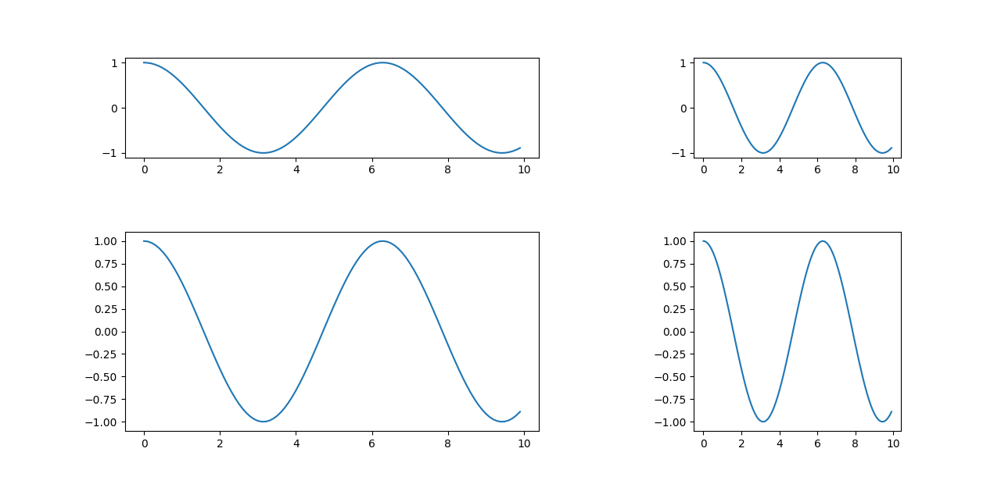

**Task 7:-** **How to Create Different Subplot Sizes in Matplotlib? Create Different Subplot Sizes in Matplotlib gridspec_kw**

**Python Code:**

import matplotlib.pyplot as plt

import numpy as np

fig, ax = plt.subplots(nrows=2, ncols=2, figsize=(7, 7),

gridspec_kw={

'width_ratios': [3, 3],

'height_ratios': [3, 3],

'wspace': 0.4,

'hspace': 0.4})

x = np.arange(0, 10, 0.1)

y = np.tan(x)

ax[0][0].plot(x, y)

ax[0][1].plot(x, y)

ax[1][0].plot(x, y)

ax[1][1].plot(x, y)

plt.show()

**Output:**



**Task 8:-** **How to Create Different Subplot Sizes in Matplotlib? Create Different Subplot Sizes in Matplotlib subplot2gridPython Code:**

import matplotlib.pyplot as plt

import numpy as np

fig = plt.figure()

fig.set_figheight(6)

fig.set_figwidth(6)

ax1 = plt.subplot2grid(shape=(3, 3), loc=(0, 0), colspan=3)

ax2 = plt.subplot2grid(shape=(3, 3), loc=(1, 0), colspan=1)

ax3 = plt.subplot2grid(shape=(3, 3), loc=(1, 2), rowspan=2)

ax4 = plt.subplot2grid((3, 3), (2, 0))

ax5 = plt.subplot2grid((3, 3), (2, 1), colspan=1)

x = np.arange(0, 10, 0.1)

y = np.cos(x)

ax1.plot(x, y)

ax1.set_title('ax1')

ax2.plot(x, y)

ax2.set_title('ax2')

ax3.plot(x, y)

ax3.set_title('ax3')

ax4.plot(x, y)

ax4.set_title('ax4')

ax5.plot(x, y)

ax5.set_title('ax5')

plt.tight_layout()

plt.show()

**Output:**



**Task 9:-** **How to set the spacing between subplots in Matplotlib in Python? Using tight_layout() method to set the spacing between subplots**

**Python Code:**

import numpy as np

import matplotlib.pyplot as plt

x=np.array([1, 2, 3, 4, 5])

fig, ax = plt.subplots(2, 2)

ax[0, 0].plot(x, x)

ax[0, 1].plot(x, x*2)

ax[1, 0].plot(x, x*x)

ax[1, 1].plot(x, x*x*x)

fig.tight_layout()

plt.show()

**Output:**

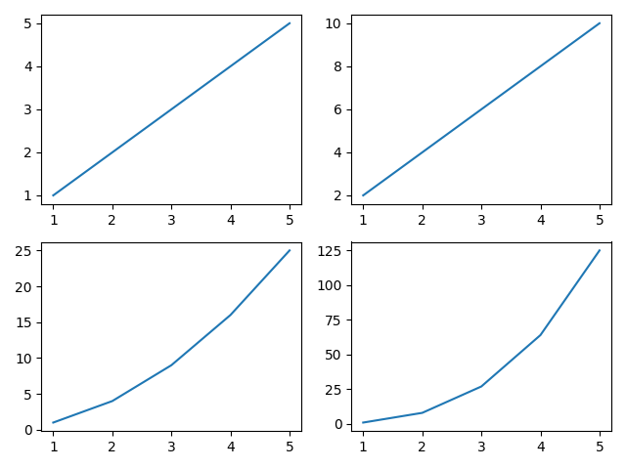

**Task 10:-** **How to set the spacing between subplots in Matplotlib in Python? Using pad**

**Python Code:**

import numpy as np

import matplotlib.pyplot as plt

x=np.array([1, 2, 3, 4, 5])

fig, ax = plt.subplots(2, 2)

ax[0, 0].plot(x, x)

ax[0, 1].plot(x, x*2)

ax[1, 0].plot(x, x*x)

ax[1, 1].plot(x, x*x*x)

fig.tight_layout(pad=5.0)

plt.show()

**Output:**